Creating a sending Travel Tracker Surveys

Access the database user export to export all Travel Tracker users | http://appgardendev.app-garden.com/TravelTrackMaster.nsf
Delete the development site and all other sites not being surveyed. | 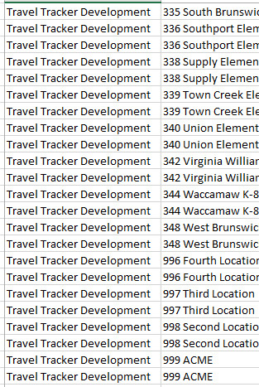
Copy and paste all the users into a blank workbook. | 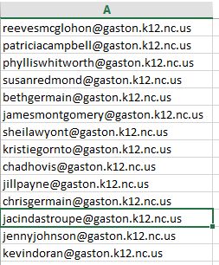
Data and Remove Duplicates | 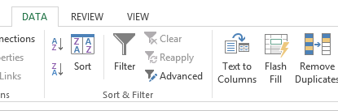
Save this file to be uploaded into Constant Contact.
Log into Constant Contact | www.constantcontact.com
Login/Password | tcook@cookconsulting.net cci5358x
Go to Contacts | 
Click “+” to add new list | 
Name the new list | 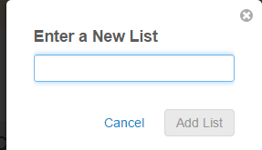
Click on the list
Add Contact from File | 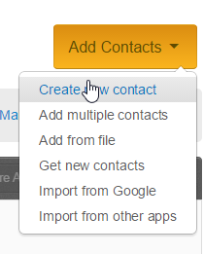
Choose the file | 