Contents
Travel Tracker Table Setup Guide 3
Locations Table 3
Trip Types and Rates 5
Vehicle Types 6
Vehicle Statuses 6
Vehicles 6
Approved Charters 6
Car Dealerships 6
Funding Sources 7
Special Indicators 7
Field Trip Events 7
Technology 7
Services 7
Athletic Events 7
Vehicle Condition Rates 7
Additional Vehicle Charges 8
Destinations Categories 8
Common Travel Destinations 8
Prospective Common Destinations 8
Special Travel Needs 8
Third Party Payment Options 8
Yellow Bus Codes 9
Driver Rates 9
Drivers 9
Mechanics 9
Curriculum/Standards/Objectives 9
Gas Prices 9
Configuration Settings 10
General Trip Message 10
Field Trip Message 10
Lead Days 10
Chaperone Rules 10
Permission Slip Message 10
Trip Ticket Message 11
Administration Options 11
Other Setup Decisions 12

Travel Tracker Table Setup Guide

Locations Table
The locations table is used to enter all school-based locations (such as the schools themselves, transportation, or locations where buses are housed). This table indicates who approves trips for that location and who the contacts are for things like Child Nutrition notifications, bookkeepers etc. It also indicates the order of locations to use for assigning buses. | 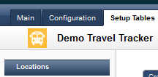  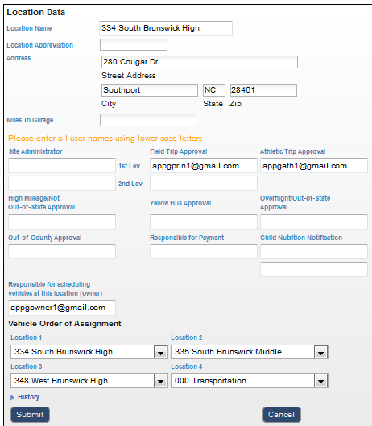
Location Name:  The location name should be listed in the format of a 3 digit location code and name. Avoid using dashes | 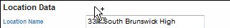

Location Abbreviation:  This is used on the trip calendar, so it should be filled in for every location – for example, for South Brunswick High School it would probably be SBHS | 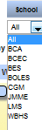
Address  The address is used for the google maps interface and should be complete. Must use street address, not PO Box. | 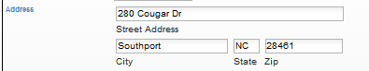
Miles to Garage
The miles to garage is used if a district adds or subtracts mileage from the school to the bus garage for the pickup of buses. This is used in the invoicing if they add or subtract pickup miles.
Site Administrator  There are two options for Site Administrator. Individuals listed as Site Administrators have full access to their location; however, they don’t receive email notifications. Make sure the vehicle owner is also listed as the site administrator. Need this in order to be able to print all trip tickets from the calendar. | 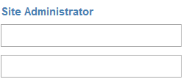
Field Trip Approval  Each site may have up to 2 levels of approval. Each approver receives email notification that they have trips to approve. | 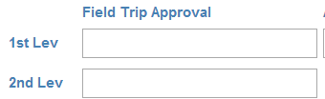
Athletic Trip Approval  There can be one athletic approver per site. If the trip requestor is also the Athletic Approver the trip is automatically approved. | 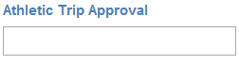
High Mileage/Not OFS Approval  Sometimes School Boards require extra approval if trips are a certain number of miles; however, the trip may not be out of state. | 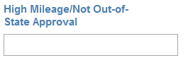
Yellow Bus Approval  Some districts require Central Office approval in order to use a yellow bus. Yellow bus regulations in some states have specific guidelines for use for field trips. | 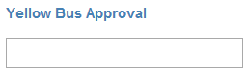
Overnight/Out-of-State Approval  This person is usually a Central Office level approver. The header on this approval may be edited in the Configuration tab to change the label. | 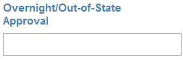
Out-of-County Approval  This allows for an extra approval if a trip goes outside their county. | 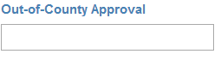
Responsible for Payment  This is the building level bookkeeper who is responsible for paying invoices for their school. | 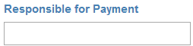
Child Nutrition Notification  There can be up to two individuals who may receive email notifications for field trips. This is usually the school cafeteria manager and then possibly the District Child Nutrition Director. | 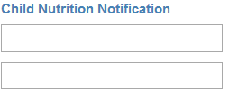
Vehicle Owner  This is the individual who is responsible for assigning the vehicle to a specific trip. They have authority only to the vehicles assigned to their location. The vehicle owner should also be listed as the site administrator. This is so they can see all the trips on the Daily Vehicle Schedule in order to print trip tickets. | 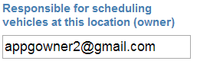
Vehicle Locations  This is the order in which vehicles may be assigned for this particular location. If there are no vehicles in Location 1 the trip is passed to the vehicle owner for Location 2, etc. Location 4 should be Transportation so they can receive the final routing should the other 3 locations be unable to complete the request. | 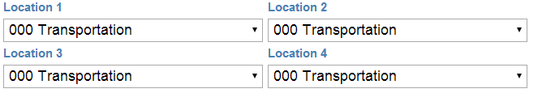

Trip Types and Rates
Cost per Mile  This is the rate schools will be charged by Transportation for using the vehicle. This is a cost per mile rate.  Auto App?  Do you want the trip to automatically approve if a certain vehicle type is selected? This is usually done with staff vehicles.  Spec Assn?  Can you create a special invoice using this vehicle type?  Vehicle Req?  If you create a special invoice for this trip type does it require you to assign a vehicle? | 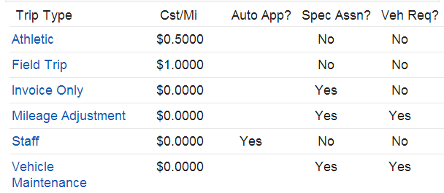

Vehicle Types
What are the vehicle types used by this district and may Staff request this vehicle. Do you want the vehicle to be automatically assigned (usually staff cars) or do you want the vehicle owner at that site to assign the specific vehicle? | 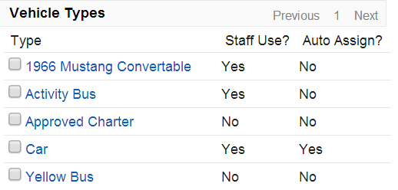

Vehicle Statuses
Is the vehicle in service or out of service? This is an option you may choose in the vehicle setup table. | 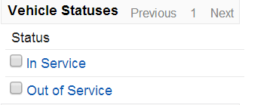

Vehicles
Required fields are Number, Type, Location & Status.  Other fields may be helpful especially student capacity as this displays for the vehicle owner when assigning the vehicle. | 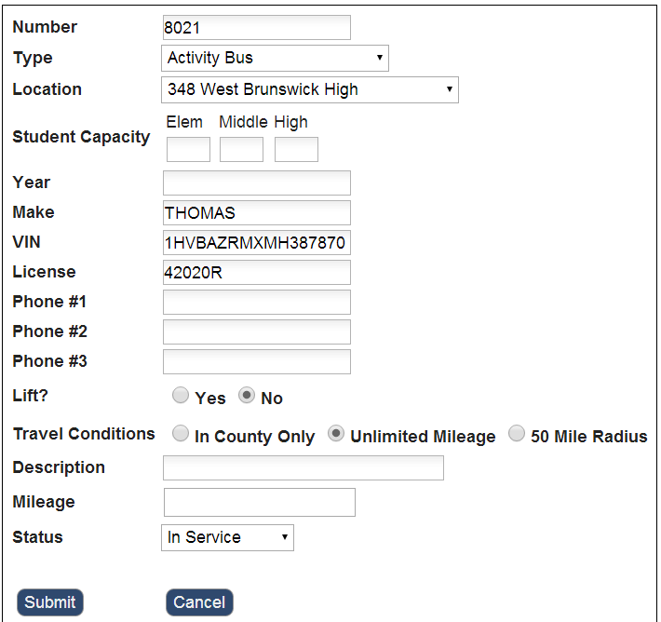

Approved Charters
Districts should provide you with a list of their approved Charter Bus Companies. If they provide an email address, the contact at the charter company will be emailed when a request is made for a charter bus. | 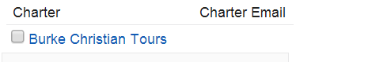

Car Dealerships
Some districts don’t have staff cars but allow administrators to rent vehicles from approved dealerships. If they provide an email address the contact at the dealership will be emailed when a request is made for a vehicle. | 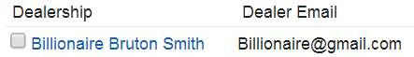

Funding Sources
Districts have the ability to add funding sources and to require that these be selected. If you require funding source be selected you will need to make sure you have School Funded as an option. Adding an email address adds that funding manager to the approval process for those trips. | 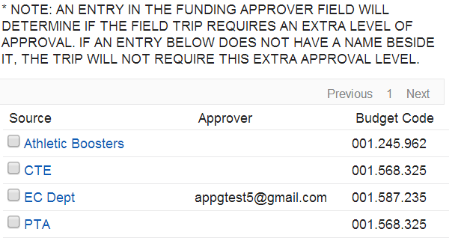

Special Indicators
This is not a required field. This gives districts the ability to generate reports on these indicators. | 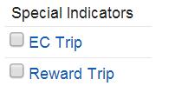

Field Trip Events
This gives districts the ability to track certain events within the field trip request. | 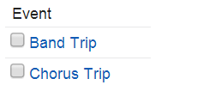

Technology
This allows a district to set up an in-house event such as a meeting where they may request equipment. | 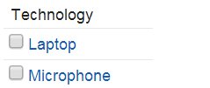

Services
Allows a district to request certain in-house services such as Kitchen, Custodial, etc. | 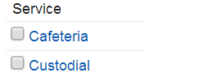

Athletic Events
Allows districts to set up the athletic events for their school system. This becomes a choice when requesting an athletic trip. | 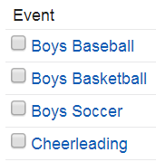

Vehicle Condition Rates
This allows districts to set rates that may be selected and added to the total invoice costs before it is released to the school bookkeepers. | 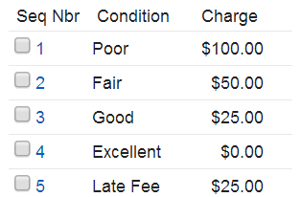

Additional Vehicle Charges
Only one Vehicle Condition Rate may be selected per invoice. This additional vehicle charge allows districts to choose a 2nd charge to be added to the invoice. Example, they may need to charge a cleaning charge and a late fee. | 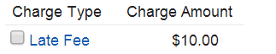

Destinations Categories
The common places school districts go for field and athletic trips are entered in a setup table. Each destination is assigned a category. These are the possible categories. | 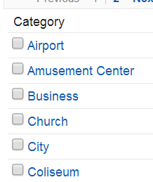

Common Travel Destinations
These are the common places this district may travel to for field and athletic trips. It is very important to have this in the setup table for accurate round trip mileage. | 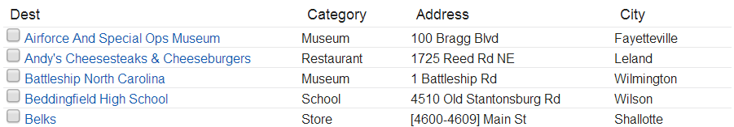

Prospective Common Destinations
Every time a trip is entered and the common destination is manually entered that destination is added to this table. Trans. Admins. should review this table frequently and choose to remove from the list or to add to the Common Travel Destinations table.

Special Travel Needs
This allows districts to set up special travel needs a requestor may have in addition to a lift. This might be seats for Pre-K students, etc. | 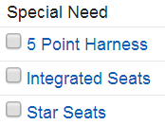

Third Party Payment Options
This option allows the requestor to request a check in advance of the field trip. This emails the bookkeeper at the school letting them know a check is needed before the trip occurs. | 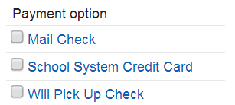

Yellow Bus Codes
It is very important that the Transportation Admin. enter the correct amount for yellow bus charges. The breakdown of this is necessary for State reporting. | 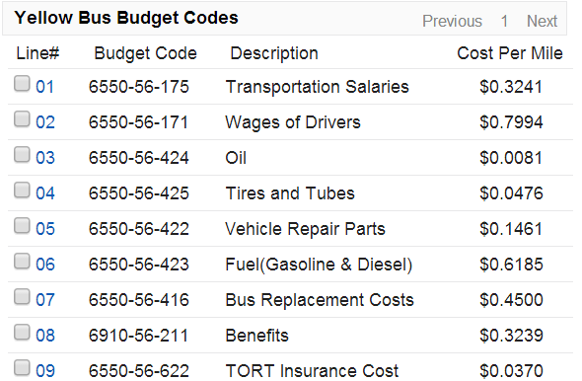

Driver Rates
Driver rates are used on the invoicing piece of TT. This gives Transportation a dropdown option for adding the driver rate/pay to the invoice. | 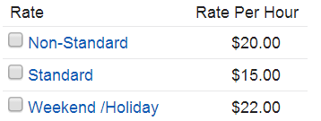

Drivers
This gives the district the ability to enter all of their drivers. The driver may then be selected from a dropdown menu. If the email address for the driver is entered and this option is turned on in the configuration, the driver will be email notified when assigned to a trip. | 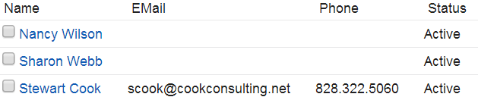

Mechanics
Allows districts to enter their mechanics for assigning them to Charter Bus inspections. | 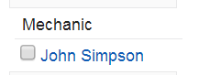

Curriculum/Standards/Objectives
Curriculum  Allows the district to set up their subject areas to be selected when requesting a trip. | 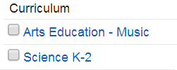
Standards  Allows the district to choose from the Common Core Standards. | 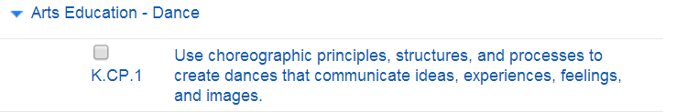
Objectives  These are the very specific objectives from the Common Core Standards. | 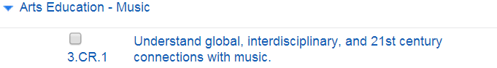

Gas Prices
This gives the district the ability to charge per mile and for the exact price paid for the gasoline. | 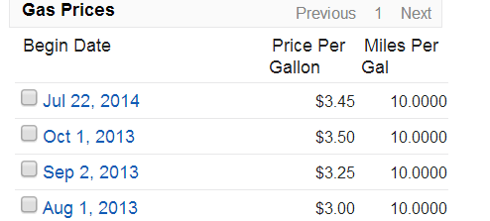

Configuration Settings

General Trip Message
The general trip message is the first thing a requestor sees when they create a trip request. This is an opportunity for the district to welcome the requestor and give instructions. | 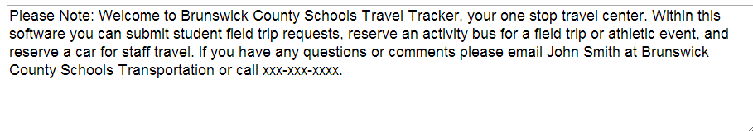

Field Trip Message
The field trip message is the last thing a requestor sees when submitting a request. They are required to indicate they have read this message. This message is more the do’s and don’ts of a field/athletic trip. | 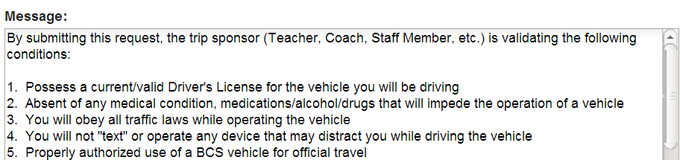

Lead Days
Lead days are the number of days a trip must be requested prior to the trip occurring. This may be a warning or prevent submission. We recommend a warning as preventing a submission would require a Transportation Admin. to submit the trip. | 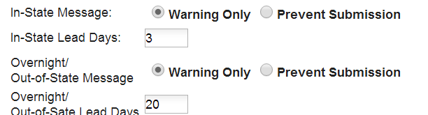

Chaperone Rules
Chaperone rules give the district the ability to monitor the adult to student ratio on trips. If the district requires 1 adult for every 10 students and the requirement is set to YES then the trip could not be submitted unless these ratios are met. | 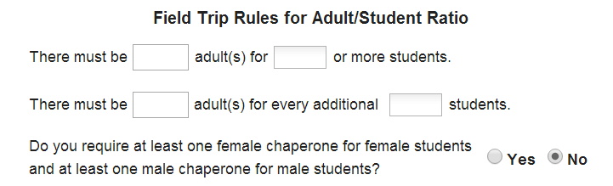

Permission Slip Message
The permission slip is divided into three sections. Each of these sections may be customized by the district. These sections along with the trip information make up the permission slip. You must also turn the permission slip on in the Other Setup Decisions section of the Configuration. | 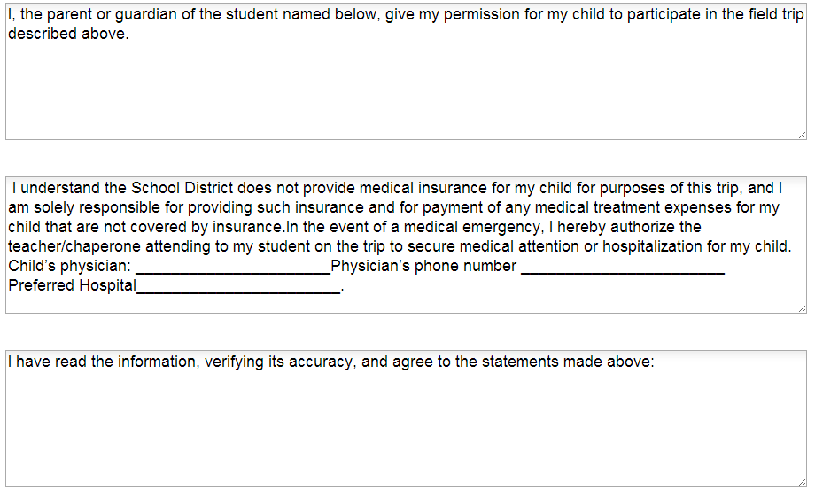

Trip Ticket Message
The trip ticket message allows you to provide instructions or messages to the driver. You must turn the trip ticket option on in the Other Setup Decisions section of the Configuration. | 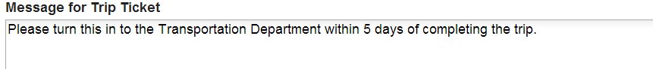

Administration Options
User Name Method
This option is set when the database is built and should not be changed.
Place Bar Name of Database  This is the name of the database. This might be XXX County Schools Travel Tracker. | 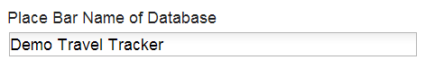
Company Name  This would be the name of the school district. | 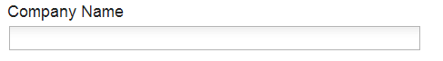
Company Address  Adding the company address adds this to the top of all the special invoices created. | 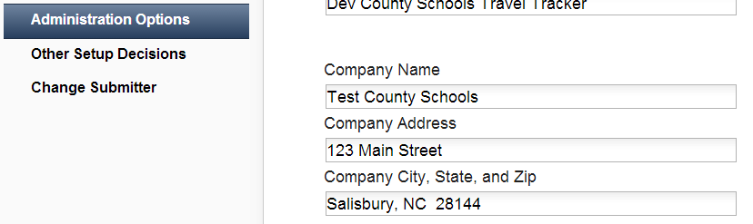
Transportation Administrator Users  This is where you enter all the users you want to have administrative rights to your database. These users have full access to edit the setup tables. | 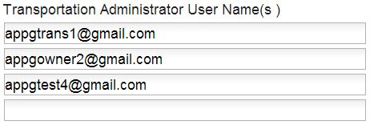
User Posting Payments  You may have up to 2 individuals who will actually post the payments. This is typically someone in Finance but could be Transportation. | 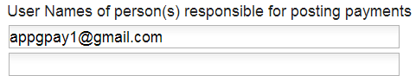
User for Overnight/Out-of-State  This is the email of the person who would need access to the Export tab for the Board Report. This is typically the Superintendent’s Admin. Asst. This is not the person who approves the trips, they are listed in each location in the Location Setup Table. | 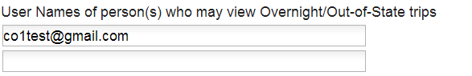
User for Vehicle Concerns  This is typically the Transportation Director. This is the person to receive the notification if there are concerns with a vehicle. | 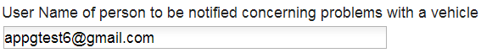
Charter Bus Inspector
This is the person who will be notified if a Charter Bus needs an inspection prior to a trip occurring.

Other Setup Decisions
This requires beginning and ending mileage be entered. If you want to enter beginning and ending mileage but also want the option to invoice based on google miles then you would select NO for this option. We recommend selecting NO.
This sends the school level bookkeeper an email reminder once per week if and only if they have outstanding invoices.
Each district determines whether or not teachers/coaches may request a yellow bus. This is most used in NC. A lot of other districts use only yellow buses for field and athletic trips.
If yellow buses are allowed who assigns the yellow buses. If you say no to this question then you must list Transportation as Location 4. If the schools have their own vehicle owners it works best to allow them to assign the yellow buses also.
Do you want to add minutes to the pickup and return times? Example, my trip is from 8:00 a.m. – 2:00 p.m. If I add 15 minutes gap time the vehicle will be reserved from 7:45 a.m. – 2:15 p.m.
Does the district require extra approval if a trip goes over a certain number of miles even if it is not overnight or out-of-state?
This is optional but would allow you to add in the cost of a sub to the trip estimator.
This comes from the Common Core Standards.
Do you want miles from the school to the Garage to add to the total miles or to subtract from the total miles? It does neither if you leave the miles to the garage field blank in the location tables.
If you use the staff vehicle feature which vehicle would you like to default for the staff vehicle?
This gives you the ability to add a flat rate to all trips meeting the indicated criteria. This might be used for maybe charging a flat dollar amount to every activity bus used. This adds to every invoice generated with this criteria. | 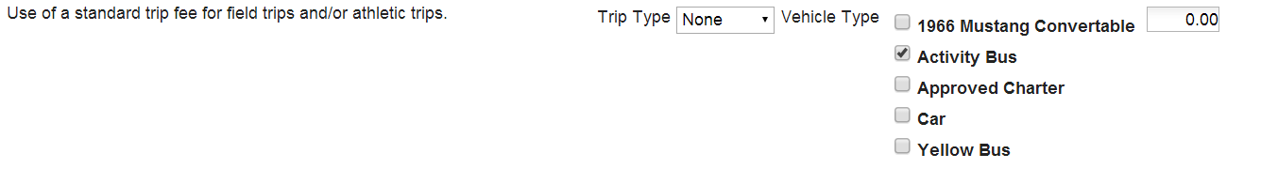
Allows you to change the label for the Overnight/Out-of-State field on the request form. Example, one district requires extra approval for Overnight/Out-of-State/Extended Day trips.
Allows you to change the label for the Persons Making the Trip. Example, one district requires the names of all their trip chaperones. Theirs says Description of Group or Person(s) making trip along with a list of the names of all the chaperones.
This allows you to request an In-House Event such as maybe a parent involvement meeting. If this is turned on the requestor may also request things such as microphones, laptops, etc.
Allows you to require all your submitters to choose the funding source from a dropdown menu. The funding sources are entered in the setup tables.
Allows you to require all your athletic submitters to choose the funding source from a dropdown menu. The funding sources are entered in the setup tables.
Gives you the ability to require the exact budget code be entered into the trip. You indicate in this option at which level the code is required.
Gives you the ability to require the exact budget code be entered for athletic trips. You indicate in this option at which level the code is required. | 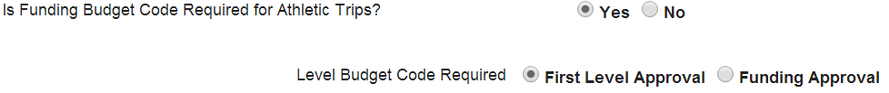
Turns on the email notifications for vehicle owners. This might be turned off in districts where Transportation assigns all of the vehicles and chooses not to be sent emails for each individual request.
Allows the district to send email notifications to the driver when they have been assigned to a trip. In order for this to work the driver’s email address must be included in the setup table for Drivers.
Gives you the ability to email the primary contact at each charter company when a charter bus is requested. The email address must be entered in the Charter Bus setup table.
Gives you the ability to email the primary contact at a car dealership when a rental car has been requested. The email address must be entered in the Dealership setup table.
Allows the district to ask the requestor to indicate if a driver is needed. Some districts want this turned off because they feel it says someone else is securing the driver and could be confusing.
This requires the requestor to answer the question “Do you need a driver”. Again this could make the requestor feel they don’t need to secure a driver.
This is an option to show the “Download Trip Ticket” button on the daily schedule view. Some districts do not want that option on this view.

